

**SMART TRAFFIC CLEARANCE AND SIGNAL CONTROL SYSTEM USING RSSI & RFID**

**A PROJECT REPORT**

***Submitted by***

|  |  |
| --- | --- |
| **KAMESH KUMAR.K** | **(190801073)** |
| **KARTHIKEYAN.H** | **(190801081)** |
| **HARIPRASAD.R** | **(190801504)** |

***in partial fulfillment for the award of the degree***

***of***

**BACHELOR OF ENGINEERING**

**IN**

**ELECTRONICS AND COMMUNICATION ENGINEERING**

**RAJALAKSHMI ENGINEERING COLLEGE**

**(AUTONOMOUS)**

**CHENNAI – 602 105**

**ANNA UNIVERSITY: CHENNAI 600 025**

**APRIL 2023**

**BONAFIDE CERTIFICATE**

Certified that this project report **“SMART TRAFFIC CLEARANCE AND SIGNAL CONTROL SYSTEM USING RSSI & RFID”** is the bonafide work of **“KAMESHKUMAR.K (190801073), KARTHIKEYAN.H (190801081), and HARIPRASAD.R (190801504)”** who carried out the project work under my supervision.

**SIGNATURE SIGNATURE**

**Dr.M.PALANIVELAN, M.E., Ph.D., Mr.S. MOHANRAJ, B.Tech., M.E.,**

**HEAD OF THE DEPARTMENT SUPERVISOR**

Professor, Assistant Professor (SS),

Department of Electronics and Department of Electronics and

Communication Engineering, Communication Engineering,

Rajalakshmi Engineering College, Rajalakshmi Engineering College,

Thandalam, Chennai – 602 105. Thandalam, Chennai – 602 105.

Submitted to Project and Viva-Voce Examination held on _____________

**Internal Examiner External Examiner**

**ACKNOWLEDGEMENT**

We thank God Almighty for enabling us to complete our project work. Our sincere thanks to our Chairperson **Dr. (Mrs.) Thangam Meganathan**, for her sincere endeavor in educating us in his premier institution. We like to express our deep gratitude to our beloved Vice Chairman **Mr. Abhay Shankar Meganathan, B.E., M.S.** for his enthusiastic motivation which is a lot in completing this project.

We would like to thank our Principal **Dr. S.N. Murugesan, M.E., Ph.D.,** for his kind support and the facilities provided to carry out our work. We would also like to thank our Head of the Department **Dr. M. Palanivelan, M.E., Ph.D.,** and Academic Head **Dr. L. Bhagyalakshmi,** **M.E., Ph.D.,** for giving the opportunity and facilities to complete our work in time.

We take this opportunity to express our profound gratitude and deep regards to our Supervisor **Mr. S. Mohanraj B.Tech., M.E., Assistant professor (SS),** Department of Electronics and Communication Engineering for his/her exemplary guidance, monitoring and constant encouragement throughout the course of this project.

We express our gratitude to the project coordinators **Ms.Anitha Mary M, Ms.Tamilarasi M, Ms.Indhumathi G and Dr.Vinodhini S V** for their kind co-operation in doing our project work. We also would like to thank our parents and classmates for their moral support and valuable suggestions in the project.

**ABSTRACT**

Traffic congestion is a significant challenge that affects the response time of emergency vehicles. The delay can result in loss of lives, property damage, and accidents. Therefore, an efficient traffic control system for emergency vehicles is critical. The proposed system is based on Radio Frequency Identification (RFID) and Radio Signal Strength Indicators (RSSI) to monitor and control traffic flow. The system works by installing RFID tags on emergency vehicles, and RSSI receivers on traffic lights and intersections. When an emergency vehicle approaches, the RFID tag sends a signal to the RSSI receiver, which triggers a green light for the vehicle. The system also utilizes vehicle-to-vehicle communication. The system allows emergency vehicles to communicate with other vehicles on the road to control their speed and movements. In this system, each vehicle is equipped with a device that communicates with other vehicles on the road. When an emergency vehicle approaches, it sends a signal to other vehicles, requesting them to move to the side of the road. The system also allows the emergency vehicle to control the speed of other vehicles, ensuring that they do not obstruct the path of the emergency vehicle. The proposed system provides a comprehensive traffic control solution for emergency vehicles that can significantly improve response times and reduce the number of accidents

|  |  |  |  |  |  |
| --- | --- | --- | --- | --- | --- |
|  | | **TABLE OF CONTENTS** | |  | |
| **CHAPTER**  **NO.** | | **TITLE** | | **PAGE**  **NO.** | |
|  | | **ABSTRACT** | | **iv** | |
|  | | **LIST OF TABLES** | | **v** | |
|  | | **LIST OF FIGURES** | | **vii** | |
| **1** | | **INTRODUCTION** | | **1** | |
|  | | 1.1 OBJECTIVE | | **1** | |
|  | | 1.2 TECHNOLOGY STACK USED | | **2** | |
| **2** | | **REVIEW OF LITERATURE** | | **3** | |
| **3** | | **EXISTING SYSTEM** | | **5** | |
| **4** | | **PROPOSED METHODOLOGY** | | **7** | |
| **5** | | **HARDWARE SPECIFICATIONS** | | **10** | |
|  | | 5.1 HARDWARE REQUIREMENTS | | **10** | |
|  | | 5.1.1 ESP8266 NODEMCU | | **10** | |
|  | | 5.1.2 ARDUINO UNO | | **13** | |
|  | | 5.1.3 16X2 LCD DISPLAY | | **17** | |
|  | | 5.1.4 DC MOTOR | | **19** | |
|  | | 5.1.5 ZIGBEE | | **20** | |
|  | | 5.1.6 RSSI | | **23** | |
|  | | 5.1.7 RFID | | **25** | |
|  | | 5.1.8 APR VOICE MODULE | | **26** | |
|  | | 5.2 SOFTWARE REQUIREMENTS | | **27** | |
|  | | 5.2.1 ARDUINO IDE | | **28** | |
| **6** | | **RESULTS AND DISCUSSION** | | **31** | |
|  | | 6.1.1 ARDUINO IDE RESULTS | | **31** | |
|  | | 6.1.2 V2V DISPLAY MESSAGES | | **33** | |
| **7** | | **CONCLUSION** | | **34** | |
|  | | 7.1 CONCLUSION | | **34** | |
|  | | 7.2 FUTURE SCOPE | | **34** | |
|  | | **REFERENCE** | | **35** | |
|  | | **APPENDIX** | | **38** | |
|  | **LIST OF FIGURES** |  | |
| **FIGURE**  **NO.** | **TITLE** | **PAGE**  **NO.** | |
| 4.1 | RECEIVER SECTION 1: VEHICLE | 8 | |
| 4.2 | RECEIVER SECTION 2: TRAFFIC SIGNAL | 9 | |
| 5.1 | NODE MCU | 10 | |
| 5.2 | ARDUINO UNO | 14 | |
| 5.3 | LCD DISPLAY | 17 | |
| 5.4 | DC MOTOR | 19 | |
| 5.5 | ZIGBEE | 21 | |
| 5.6 | RSSI RANGE | 24 | |
| 5.7 | RFID READER & RFID TAG | 25 | |
| 5.8 | APR VOICE MODULE | 27 | |
| 5.9 | ARDUINO IDE | 29 | |
| 6.1 | SYSTEM RESULTS | 31 | |
| 6.2 | WHEN AMBULANCE IS NOT DETECTED. | 32 | |
| 6.3 | WHEN AMBULANCE IS DETECTED & CONNECTED TO THE NETWORK | 32 | |
| 6.4 | WHEN AMBULANCE IS CLOSER | 33 | |
| 6.5 | WHEN AMBULANCE IS NEAR | 33 | |
| 6.6 | WHEN AMBULANCE IS FAR | 33 | |

**CHAPTER 1**

**INTRODUCTION**

Traffic congestion is a major problem in cities worldwide, and it has a significant impact on our daily lives. The problem is particularly severe in urban areas with large populations, where the number of vehicles on the road is constantly increasing. The growth in vehicle numbers has made it challenging to maintain a smooth flow of traffic, especially during peak hours. Traffic congestion results in a range of problems, including increased air pollution, increased fuel consumption, and time wasted in traffic jams. It also makes it challenging for emergency vehicles to navigate through the traffic, resulting in delayed responses, which can lead to fatalities and property damage. Several factors contribute to traffic congestion, such as urbanisation, poor infrastructure, and traffic accidents. More people are commuting to work and education as a result of urban population growth, which adds to the number of vehicles on the road. Traffic congestion has significantly increased as a result, particularly during peak hours. Also, as a result of urbanisation, more buildings have been built, increasing the number of vehicles on the road. Road accidents are another issue that makes traffic clog up. Accidents may cause delays and road closures, which will exacerbate traffic. The fact that emergency vehicles, such as ambulances and fire trucks, find it difficult to navigate through the traffic to get to the scene of an accident just makes the issue worse.

August 7, 2021, a major accident occurred on the Mumbai-Pune Expressway in India. The accident involved a bus carrying passengers and a truck, and it resulted in the deaths of at least six people and injuries to several others. The accident occurred in the early morning hours, and it caused significant traffic delays on the expressway. Emergency services responded to the scene, and an investigation into the cause of the accident is ongoing. The accident highlights the need for effective traffic control systems and road safety measures to prevent such incidents from occurring in the future.

* 1. **OBJECTIVE**

The Automatic Traffic Control System for Emergency Vehicles is a smart solution that leverages advanced technologies such as RFID, RSSI, V2V communication, and Zigbee to allow emergency vehicles to navigate through congested traffic safely and quickly. The system uses RFID tags installed in emergency vehicles to communicate with RFID readers on traffic signals, which then trigger the system to turn the light to green, allowing the emergency vehicle to pass. The system also uses V2V communication to communicate with other vehicles and alert them to clear the way for the emergency vehicle using RSSI technology. DC Motor is used to control the other vehicle's speed and direction, ensuring that the emergency vehicle reaches quickly and safely. Overall, the system aims to reduce response times, improve emergency services, and save lives.

* 1. **TECHNOLOGY STACK USED**

• RSSI (Received Signal Strength Indicator): This technology involves measuring the strength of radio signals between devices. In the context of emergency vehicle traffic control, RSSI can be used to determine the distance between vehicles and to track the movement of emergency vehicles in real-time.

• RFID (Radio Frequency Identification): RFID is a wireless technology that uses radio waves to identify and track objects. In the proposed system, RFID tags can be attached to emergency vehicles to identify them and track their movements. RFID readers can be placed at key intersections and other strategic points to detect the presence of emergency vehicles and trigger traffic signal changes.

**CHAPTER 2**

**REVIEW OF LITERATURE**

*Umar Mahmud et al*. (2022), in the paper titled **"A Distributed Emergency Vehicle Transit System Using Artificial Intelligence of Things (DEVeTS- AIoT)"** proposes a solution to address the challenge of providing efficient and timely emergency services. The system utilizes the Internet of Things (IoT) and Artificial Intelligence (AI) to create a distributed emergency vehicle transit system. The proposed system uses a network of sensors, AI algorithms, and IoT devices to optimize traffic routes and traffic light timings for emergency vehicles. The system also utilizes a distributed decision-making approach to provide efficient and effective emergency services.

*S. Hussain et.al.* (2022), in the paper titled **“Car e-talk: an IoT-enabled cloud-assisted smart fleet maintenance system”** proposed a solution using an IoT- enabled cloud-assisted smart fleet maintenance system that aims to improve the maintenance of commercial vehicle fleets. It works by leveraging IoT technologies to collect and analyze real-time data from sensors and other sources, such as vehicle diagnostics and GPS location. The system then uses artificial intelligence and machine learning algorithms to analyze the data and predict potential maintenance issues before they occur.

*S. S. Anusha et al.* (2021), in the paper titled **"Wireless Traffic Control System for Emergency Vehicles Using ZigBee and RSSI"** proposes a system consists of two main components: a ZigBee-based communication module installed in the emergency vehicle, and a ZigBee-based traffic light control module installed at traffic intersections. The two modules communicate with each other using the ZigBee protocol. The RSSI value is used to determine the distance between the vehicle and the traffic light. The proposed system utilizes the RSSI values to prioritize emergency vehicles over regular traffic and ensures that they get a green light at intersections

*Uzma Iqbal et.al* (2020), in the paper titled **"Smart Emergency Vehicle Traffic Control System using Zigbee and RFID"** proposes a system aims to provide a seamless passage to emergency vehicles, reducing the response time to emergency situations. The system consists of an RFID reader and Zigbee module installed at every intersection, which communicates with the emergency vehicle equipped with an RFID tag and Zigbee module. The system allows emergency vehicles to prioritize their passage by automatically changing the traffic signal to green at the approaching intersection.

*A. Ramesh et al.* (2020), in the paper titled, **“Design and Implementation of a Smart Traffic Control System for Emergency Vehicles Using ZigBee Technology”** proposes a smart traffic control system for emergency vehicles using ZigBee technology. The system consists of an emergency vehicle equipped with a ZigBee module and a traffic signal equipped with another ZigBee module. It communicates with each other and help in controlling the traffic signal to allow the emergency vehicle to pass through smoothly. The system also includes a web-based application that displays the location of the emergency vehicle and controls the traffic signals. The proposed system helps in reducing the response time of emergency services and improves their efficiency.

**CHAPTER 3**

**EXISTING SYSTEM**

**"Wireless Traffic Control System for Emergency Vehicles Using ZigBee and RSSI"** proposes a system consists of two main components: a ZigBee-based communication module installed in the emergency vehicle, and a ZigBee-based traffic light control module installed at traffic intersections. The two modules communicate with each other using the ZigBee protocol. The RSSI value is used to determine the distance between the vehicle and the traffic light.

**Pros:**

❖ The system uses low-power Zigbee technology, which is energy efficient.

❖ The system has the ability to detect emergency vehicles from a distance, allowing for timely response to emergency situations.

❖ Low cost.

**Cons:**

❖ The system may have limited range and may not be effective for tracking emergency vehicles over long distances.

❖ No Vehicle2Vehicle Communication.

**“Intelligent IoT systems for traffic management”** proposes a network of sensors and cameras to collect traffic-related data, which is then processed and analyzed to provide real-time traffic information to users. The system uses machine learning algorithms to predict traffic patterns and optimize traffic flow.

**Pros:**

❖ The use of intelligent IoT systems can help in reducing traffic congestion and improving traffic flow.

❖ Cost savings can be achieved through efficient traffic management.

**Cons:**

❖ Implementation costs can be high, particularly for large-scale projects.

❖ Privacy concerns may arise with the collection and use of personal data through IoT devices.

**"A Distributed Emergency Vehicle Transit System Using Artificial Intelligence of Things (DEVeTS- AIoT)"** proposes a system uses a network of sensors to collect real-time traffic data, which is then analyzed using AI algorithms to optimize traffic routes for emergency vehicles. The system also uses IoT devices to communicate with traffic signals, allowing the system to control traffic signals and give priority to emergency vehicles.

**Pros:**

❖ The system is designed to improve the efficiency and timeliness of emergency services, which can save lives in critical situations.

❖ The use of IoT and AI technologies allows for real-time data analysis and decision-making, improving the efficiency of the system.

**Cons:**

❖ The system may require significant infrastructure changes to be implemented, which could be challenging in densely populated urban areas.

❖ The system may require significant investment in sensors and other IoT devices, which can be expensive

**CHAPTER 4**

**PROPOSED METHODOLOGY**

In this proposed method, the Traffic Control System for Emergency Vehicles is a cutting-edge solution that uses a combination of advanced technologies to improve the response times of emergency vehicles during times of heavy traffic. The system is made up of several components, including RFID, RSSI, V2V communication, Zigbee, and DC motor.

The RFID component of the system involves the installation of RFID tags on the emergency vehicles. These tags are designed to communicate with RFID readers installed on traffic signals. When an emergency vehicle approaches an intersection, the RFID reader detects the tag and triggers the traffic signal to turn green, allowing the emergency vehicle to pass quickly and safely. The RSSI component of the system uses V2V communication to communicate with other vehicles on the road. When an emergency vehicle approaches, the system sends a signal to other vehicles in the vicinity, alerting them to clear the way for the emergency vehicle. This signal is sent using RSSI technology, which measures the strength of the radio signal between two devices to determine their proximity to each other.

The V2V communication component of the system is critical to its success, as it enables emergency vehicles to navigate through heavy traffic safely and quickly. Using this technology, emergency vehicles can communicate with other vehicles on the road, providing them with real-time information about their location and speed. This information is used to control the speed and direction of the other vehicles, ensuring that the emergency vehicle can pass safely and quickly.

**Fig.4.1 Receiver section 1: Vehicle**



**POWER SUPPLY**

**RSSI**

**LCD**

**MOTOR DRIVER**

**ARDUINO UNO**

**APR MODULE**

**SPEAKER**

**DC MOTOR**

**ZIGBEE TX**

We connect a controller with an Arduino Uno to a DC motor and RSSI as show in the Fig:4.1. Here, the vehicle is a DC motor. The range of an ambulance truck is determined using the RSSI (Received Signal Strength Indicator).

The RSSI value indicates how well your device can pick up a signal from a network or access point. It's a number that can be used to figure out whether you have adequate signal to establish a solid wireless connection.

Also, an Arduino Uno controller to an APR voice module and a liquid crystal display. By integrating an APR speech module, the ambulance can notify the driver when it is close to oncoming traffic or far from a traffic signal. In a liquid crystal display, all the information is displayed.



**POWER SUPPLY**

**ZIGBEE RX**

**TRAFFIC SETUP**

**ARDUINO UNO**

**RFID READER**

**RFID TAG**

**Fig.4.2 Receiver section 2: Traffic Signal**

Overall, the Automatic Traffic Control System for Emergency Vehicles is a sophisticated solution that leverages advanced technologies to improve the response times of emergency vehicles. By using RFID, RSSI, V2V communication, and Zigbee, the system can navigate through congested traffic safely and efficiently, reducing response times, improving emergency services, and saving lives.

**CHAPTER 5**

## HARDWARE AND SOFTWARE DESCRIPTION

**5.1 Hardware Requirements**

**5.1.1 ESP8266 NODEMCU**

NodeMCU ESP8266 is a low-cost and highly integrated System on a Chip (SoC) that enables rapid development of IoT applications. It is based on the ESP8266 chip, which is a Wi-Fi microcontroller module that can be programmed using the Arduino IDE. NodeMCU ESP8266 has become popular in the maker community due to its ease of use, small size, and low power consumption.

NodeMCU ESP8266 has a variety of hardware features such as 16 GPIO pins, a UART, I2C, SPI, and an analog-to-digital converter (ADC). It also has an on-chip Wi-Fi module that supports 802.11 b/g/n wireless standards. This makes it possible to connect to the internet and communicate with other devices in a wireless network. The board can be powered by either a USB connection or an external power supply.

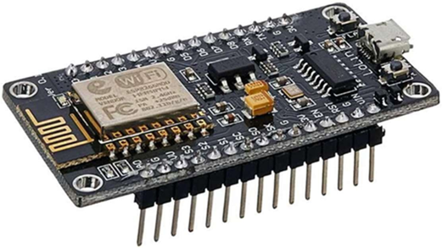

**Fig.5.1. NodeMCU**

The NodeMCU development board has a total of 11 pins, including GPIO (General Purpose Input/Output), Analog, and power pins. Here's a brief description of each pin:

1. Vin: This pin is used to supply voltage to the NodeMCU board. It accepts a voltage range of 4.5V to 9V.
2. GND: This pin is used as a ground pin. It is used to complete the circuit with the voltage supplied to the Vin pin.
3. V3: This pin provides a 3.3V power supply.
4. EN: This pin is used to enable the chip. When pulled high, the chip is enabled, and when pulled low, it is disabled.
5. RST: This pin is used to reset the chip.
6. GPIO16/D0: This pin is a digital input/output pin. It can be used for digital communication or as an interrupt.
7. GPIO5/D1: This pin is a digital input/output pin. It can be used for digital communication or as an interrupt.
8. GPIO4/D2: This pin is a digital input/output pin. It can be used for digital communication or as an interrupt.
9. GPIO0/D3: This pin is a digital input/output pin. It is also used as the boot mode selection pin.
10. GPIO2/D4: This pin is a digital input/output pin. It is also used as the boot mode selection pin.
11. A0: This pin is an analog input pin. It can read analog voltages between 0 and 3.3V.

**Procedure to Upload**

The NodeMCU ESP8266 can be programmed using Lua or the Arduino IDE. Lua is a lightweight scripting language that is easy to learn and ideal for embedded systems. The Arduino IDE is a widely used development environment for programming microcontrollers. It has a large community of developers and a vast collection of libraries that make it easy to interface with other devices and sensors. To program the NodeMCU ESP8266 using the Arduino IDE, you first need to install the ESP8266 board package. This can be done by going to File -> Preferences in the Arduino IDE and entering the following URL in the Additional Board Manager URLs field:

**http://arduino.esp8266.com/stable/package_esp8266com_index.json**

Then, go to Tools -> Board -> Boards Manager, search for "ESP8266", and install the board package. Once the board package is installed, you can select the NodeMCU board from the Tools -> Board menu and start writing your code. The NodeMCU ESP8266 can be used for a wide range of applications such as home automation, remote monitoring, and industrial control systems. It can be used to read data from sensors, control actuators, and communicate with other devices over the internet. It can also be used in conjunction with cloud services such as AWS IoT or Google Cloud IoT to build scalable and secure IoT applications.

The NodeMCU ESP8266 has numerous applications in various fields, including:

* Internet of Things (IoT) Devices: With its built-in Wi-Fi module, the NodeMCU ESP8266 is ideal for developing IoT devices. It can be used to create smart home devices, such as door locks, security cameras, and thermostats.
* Robotics: The NodeMCU ESP8266 can be used to develop robotic systems that require wireless communication. It can be used to control the movement of robotic arms, drones, and other unmanned systems.

In conclusion, NodeMCU ESP8266 is a powerful and versatile microcontroller board that enables rapid prototyping of IoT applications. Its ease of use, small size, and low power consumption make it an ideal choice for hobbyists, makers, and professional developers alike. With a rich set of hardware features, extensive software support, and a large community of developers, the NodeMCU ESP8266 is a valuable tool for anyone looking to build innovative IoT solutions.

**5.1.2 Arduino UNO**

Arduino Uno is a widely popular microcontroller board that is used in various electronic projects, from simple ones to complex ones. It is a compact and affordable board that is designed to be user-friendly, making it an ideal choice for beginners and experts alike.

The Arduino Uno is built around the ATmega328P microcontroller, which is an 8- bit AVR microcontroller with a clock speed of 16 MHz. It has 32 KB of flash memory for storing code, 2 KB of SRAM for storing data, and 1 KB of EEPROM for non-volatile storage. It has 14 digital input/output pins, 6 analog input pins, and a USB port for programming and power supply. The digital input/output pins are used to interface with other digital devices, such as LEDs, switches, and sensors. They can be configured as either input or output pins, depending on the requirements of the project. The analog input pins are used to read analog signals from sensors, such as temperature sensors and light sensors. They can also be used as digital input/output pins if required.

One of the biggest advantages of using the Arduino Uno is its ease of use. The Arduino software, which is used to program the board, is open-source and can be downloaded for free from the Arduino website. It has a simple and intuitive interface, making it easy for beginners to learn and use. Additionally, there are plenty of online resources available, including tutorials, forums, and code examples, making it easy for users to find help and support.

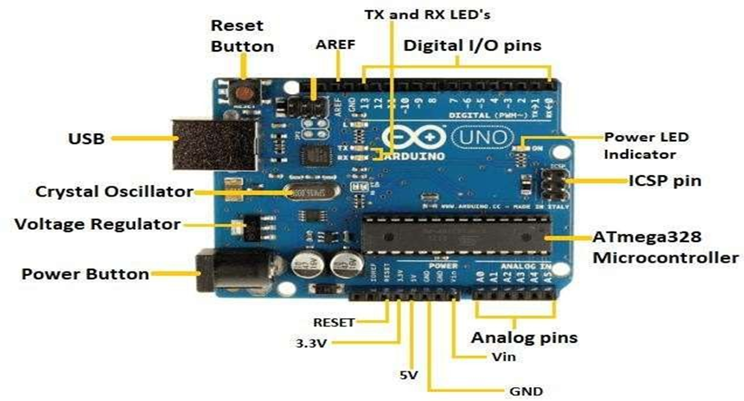

**Fig.5.2. ARDUINO UNO**

The Arduino Uno is also highly versatile. It can be used for a wide range of applications, from simple LED blinking projects to complex robotic systems. The board can be easily interfaced with a wide range of sensors and other electronic devices, making it a popular choice for IoT projects.

**Pin Description:**

The Arduino UNO has a total of 20 pins, which are divided into three categories: digital pins, analog pins, and power pins.

Here's an overview of each of these pins:

**Digital Pins:**

* Digital pins 0-13: These are the digital input/output pins of the Arduino UNO. They can be used for both digital input and output operations. These pins can be configured as either input or output using the pinMode() function in the Arduino programming language. Digital pins 0 and 1 are also used for serial communication with other devices.
* Digital pin 14 (TX): This is the transmit pin for serial communication. It is used to send data to other devices.
* Digital pin 15 (RX): This is the receive pin for serial communication. It is used to receive data from other devices.

**Analog Pins:**

* Analog pins A0-A5: These are the analog input pins of the Arduino UNO. They are used to read analog signals from sensors or other analog devices. The analog input pins can also be used as digital input/output pins.
* Power Pins:
* 5V: This is the regulated 5V power output pin of the Arduino UNO. It can be used to power external sensors or other devices that require a 5V power source.
* 3.3V: This is the regulated 3.3V power output pin of the Arduino UNO. It can be used to power external sensors or other devices that require a 3.3V power source.
* GND: These pins are the ground pins of the Arduino UNO. They are used to provide a common ground reference for the Arduino and other devices that are connected to it.
* Vin: This is the input voltage pin of the Arduino UNO. It can be used to power the Arduino from an external power source (e.g. a battery) instead of the USB port. The voltage should be between 7V and 12V.

**Procedure to upload:**

To upload a sketch to an Arduino Uno, follow these steps:

1. Connect the Arduino Uno board to your computer using a USB cable. The USB port is located on the top of the board.
2. Open the Arduino IDE (Integrated Development Environment) on your computer.
3. In the IDE, click on File > New to open a new sketch.
4. Type in or copy and paste the code for your sketch into the IDE.
5. Choose the correct board type and serial port by going to Tools > Board and selecting "Arduino Uno" from the list, and then going to Tools > Port and selecting the port that the Uno is connected to.
6. Click on the Upload button (the arrow button located at the top left corner of the IDE) to upload the sketch to the Uno board. The sketch will be compiled and transferred to the Uno, and the onboard LED (labeled "L") will blink rapidly during this process.
7. Wait for the IDE to display the message "Done uploading" at the bottom of the IDE window. Once the message is displayed, the sketch has been successfully uploaded to the Uno.
8. You can now disconnect the USB cable from the Uno board.

**5.1.3 16X2 LCD Display**

A 16x2 LCD display is a liquid crystal display with 16 columns and 2 rows of characters. It is a commonly used display module in various electronic devices such as calculators, digital clocks, and microcontrollers. The display module has a backlight that provides illumination to the characters. It operates with a low voltage (usually 5V) and can be connected to microcontrollers, computers, and other digital devices.

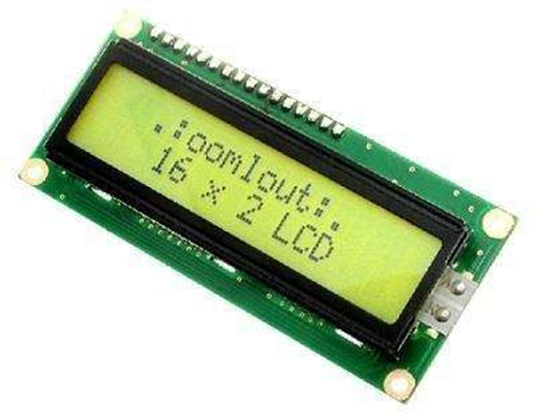

**Fig.5.3. LCD Display**

The LCD display works by utilizing the properties of liquid crystals to control the amount of light that passes through them. The liquid crystals are sandwiched between two transparent electrodes and when a voltage is applied, the crystals align to block or allow light to pass through. By changing the voltage applied to different sections of the display, characters and symbols can be created on the screen.

**Features of 16x2 LCD display:**

The module has a standard 16-pin interface that can be easily connected to a microcontroller or other digital devices.

1. The module has a standard 16-pin interface that can be easily connected to a microcontroller or other digital devices.
2. It has a backlight that can be turned on or off, providing illumination to the characters in low light conditions.
3. The display has a contrast adjustment pin that allows the user to adjust the contrast of the characters displayed.
4. It has a wide viewing angle, making it easy to read characters from different angles.
5. The display module is low power, consuming very little power even when the backlight is on.
6. It is compatible with a wide range of microcontrollers and digital devices.

The 16x2 LCD display can be used for a variety of applications such as displaying the temperature and humidity readings from a sensor, displaying the time and date, displaying messages, and even for controlling various electronic devices. It is an affordable and versatile display module that is widely used in the electronics industry.

In summary, a 16x2 LCD display is a commonly used display module in various electronic devices. It works by utilizing the properties of liquid crystals to control the amount of light that passes through them. The module has a backlight that provides illumination to the characters and is compatible with a wide range of microcontrollers and digital devices. It is low power, has a wide viewing angle, and has a contrast adjustment pin for adjusting the contrast of the characters displayed. It is an affordable and versatile display module that is widely used in the electronics industry.

**5.1.4 DC Motor**

A DC (Direct Current) motor is an electric motor that converts electrical energy into mechanical energy. It works on the principle of the Lorentz force, which states that when a current-carrying conductor is placed in a magnetic field, it experiences a force perpendicular to both the direction of the current and the magnetic field.

DC motors consist of two main components: a stator and a rotor. The stator is the stationary part of the motor, and it contains the magnets that produce the magnetic field. The rotor is the rotating part of the motor, and it contains the conductors that carry the current. When a DC voltage is applied to the motor, a current flow through the conductors in the rotor. This current creates a magnetic field around the conductors, which interacts with the magnetic field of the stator. As a result, a torque is produced, which causes the rotor to rotate.

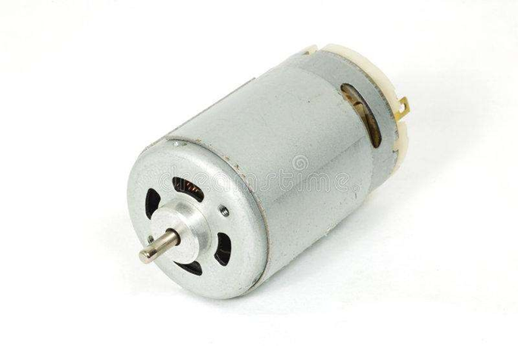

**Fig.5.4. DC Motor**

There are two types of DC motors: brushed and brushless. Brushed DC motors have brushes, which are conductive contacts that provide a path for the current to flow into the rotor. Brushless DC motors, on the other hand, use electronic controllers to switch the current to different coils in the rotor.

DC motors have several features that make them suitable for a wide range of applications. These features include:

* High torque: DC motors can produce high torque at low speeds, making them ideal for applications that require high starting torque.
* Speed control: DC motors can be easily controlled by adjusting the voltage or current supplied to the motor.
* Reversibility: DC motors can be easily reversed by reversing the polarity of the voltage applied to the motor.
* Efficiency: DC motors are highly efficient, with efficiency ratings of up to 95%.
* Low maintenance: Brushless DC motors require very little maintenance, as they do not have brushes that wear out over time.

DC motors are used in a wide range of applications, including robotics, electric vehicles, industrial automation, and consumer electronics. They are versatile, efficient, and reliable, making them a popular choice for many different types of machinery and equipment.

**5.1.5 Zigbee**

Zigbee is a wireless communication protocol designed for low-power, low- data-rate, and low-cost wireless networks. It is based on the IEEE 802.15.4 standard for wireless personal area networks (WPANs) and operates in the unlicensed 2.4 GHz band, although there are other frequency bands available for use in different regions. Zigbee was developed to provide an open standard for wireless communication that would be simple to implement, flexible, and interoperable across different devices and manufacturers. It is often used in smart homes, industrial automation, and sensor networks because of its low power consumption, small packet size, and ability to support mesh networking. They are composed of three types of devices: coordinators, routers, and end devices. The coordinator is the most important device in the network and is responsible for forming and maintaining the network, managing the communication between devices, and controlling the data flow. Routers act as intermediaries in the network, forwarding messages between devices to ensure reliable communication.

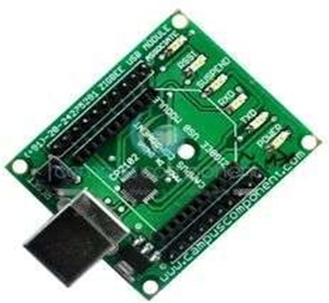

**Fig.5.5. Zigbee**

One of the key features of Zigbee is its ability to support mesh networking, which allows devices to communicate with each other even if they are not within direct range of the coordinator. In a mesh network, messages can be forwarded from device to device until they reach their destination. This means that the network can expand its coverage area and improve its reliability as more devices are added.

**ZIGBEE Tx:**

Zigbee is a wireless communication protocol that is designed for low- power, low-data rate, and short-range communication. Zigbee transmitters use radio frequency (RF) waves to transmit data wirelessly. Here is a general overview of how a Zigbee transmitter works.

1. Data Encoding: The data to be transmitted is first encoded using a protocol-specific method. This encoding process ensures that the data is transmitted reliably and without errors.
2. Modulation: The encoded data is then modulated onto a carrier signal. The modulation process determines the frequency, amplitude, or phase of the carrier signal according to the encoded data.
3. Amplification: The modulated signal is then amplified to a level that is strong enough to be transmitted wirelessly.
4. Antenna: The amplified signal is then transmitted through an antenna. The antenna radiates the signal out into the surrounding environment.
5. Frequency Channels: Zigbee transmitters use frequency channels in the 2.4 GHz band. The frequency channels used by Zigbee are different from those used by other wireless protocols, such as Wi-Fi and Bluetooth, which helps to minimize interference.
6. Communication: The transmitter communicates with the receiver through a wireless channel. The receiver demodulates the received signal to recover the encoded data.
7. Power Management: Zigbee transmitters are designed to conserve power. They use sleep modes to reduce power consumption when not transmitting data. The sleep mode is typically used when the transmitter is not needed for an extended period.

In summary, Zigbee transmitters use encoding, modulation, amplification, and an antenna to transmit data wirelessly. They operate in the 2.4 GHz band and are designed for low-power, low-data rate, and short-range communication.

**ZIGBEE Rx:**

A Zigbee receiver works in tandem with a transmitter to wirelessly transmit and receive data. Here is a general overview of how a Zigbee receiver works:

1. Antenna: The receiver starts by receiving a signal wirelessly through an antenna. The signal is usually sent by a Zigbee transmitter.
2. Amplification: The signal is then amplified to a level that can be demodulated by the receiver.
3. Demodulation: The receiver demodulates the received signal to extract the encoded data. The demodulation process recovers the original data that was modulated onto the carrier signal.
4. Decoding: The decoded data is then processed by the receiver. The receiver uses a protocol-specific method to decode the data, which ensures that the data is free from errors.
5. Power Management: Zigbee receivers are designed to conserve power. They use sleep modes to reduce power consumption when not receiving data.
6. Communication: The receiver communicates with the transmitter through a wireless channel. The transmitter and receiver may exchange acknowledgement messages to ensure the reliability of the communication.
7. Data Processing: Once the data is received and decoded, it is usually processed by a microcontroller or a computer. The processed data may be used for various purposes, such as controlling a Zigbee-enabled device or analyzing sensor data.

In summary, a Zigbee receiver works by receiving a wireless signal through an antenna, amplifying and demodulating the signal, decoding the data, and processing it. The receiver communicates with the transmitter through a wireless channel and uses power management techniques to conserve power.

**5.1.6 RSSI**

RSSI (Received Signal Strength Indicator) is a measurement of the strength of a received wireless signal. It is a metric that is commonly used in wireless communication systems to determine the quality of a received signal.

When a wireless signal is transmitted from a transmitter to a receiver, it may encounter various obstacles and interference in the environment that can affect the strength of the received signal. The RSSI is a measure of the power level of the received signal, which is typically expressed in decibels (dBm). The RSSI value is an indication of the strength of the signal relative to a reference level, which is typically a known value. The RSSI value is often used to determine the quality of the wireless link between the transmitter and receiver. A higher RSSI value generally indicates a stronger signal, which in turn may result in better communication quality. However, it is important to note that a higher RSSI value does not necessarily mean that the communication quality is better, as there may be other factors that can affect the quality of the wireless link. One of the main benefits of RSSI is that it provides a quick and easy way to determine the strength of a received signal without having to decode the actual data being transmitted. This can be useful in situations where the data being transmitted is encrypted or where it is not necessary to decode the data for a particular application.

RSSI is also used in various wireless technologies, such as Wi-Fi, Bluetooth, and Zigbee. In these technologies, the RSSI value is often used to determine the proximity of a wireless device to another device or access point. This can be useful in applications such as indoor positioning systems or asset tracking.

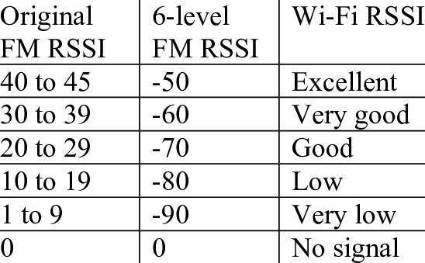

**Fig.5.6. RSSI Ranges**

**5.1.7 RFID**

RFID (Radio Frequency Identification) is a technology that uses radio waves to identify and track objects. RFID systems consist of a reader, a tag, and a computer system that manages and processes the data collected from the tags.

The RFID tag is a small electronic device that contains a microchip and an antenna. The microchip contains information about the object being tracked, such as its unique identifier, and the antenna is used to transmit this information to the reader using radio waves.The reader is a device that emits radio waves and receives signals from the tags. When a tag is within range of the reader, it sends out a signal containing the information stored on the tag. The reader then captures this signal and sends it to a computer system for processing.RFID technology has a wide range of applications, including inventory management, supply chain management, access control, and asset tracking. RFID tags can be attached to a wide range of objects, from products in a store to vehicles in a parking lot.

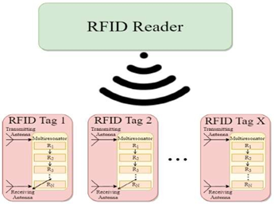

**Fig.5.7. RFID Reader & RFID Tag**

One of the key advantages of RFID technology is that it can be used to track objects without the need for direct line-of-sight contact between the tag and the reader. This means that tags can be read through walls, containers, and other obstructions, making

making it a highly versatile and effective technology for tracking objects.

Overall, RFID technology is a powerful tool for identifying and tracking objects in a wide range of applications. Its ability to operate without line-of-sight contact between the tag and the reader makes it highly effective for tracking objects in complex environments and has led to its widespread adoption in many industries.

**5.1.8 APR VOICE MODULE:**

An APR (Automatic Speech Recognition) voice module is an electronic circuit that is designed to recognize and interpret human speech. The module uses sophisticated algorithms and signal processing techniques to analyze the acoustic characteristics of human speech and convert it into digital data that can be processed by a computer or microcontroller. The main function of an APR voice module is to provide a voice interface for various applications. The module can be used to control electronic devices, provide voice feedback, or interact with other software applications. Some of the common applications of APR voice modules include speech recognition systems, voice-controlled appliances, and voice assistants.

APR voice modules typically consist of a microphone, an analog-to-digital converter, a digital signal processor, and a memory module. The microphone is used to capture the sound of human speech, which is then converted into digital data by the analog-to-digital converter. The digital signal processor analyzes the digital data and uses sophisticated algorithms to recognize and interpret the speech. The memory module is used to store the speech data and the recognition results.

When a user speaks into the microphone, the APR voice module captures the sound and analyzes it to recognize the speech. The module compares the speech data with a pre-defined set of speech patterns or vocabulary, and then produces a digital output signal that corresponds to the recognized speech

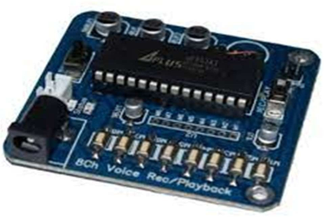

**Fig.5.7. APR Voice Module**

. The output signal can then be used to control electronic devices, provide voice feedback, or interact with other software applications.

In conclusion, an APR voice module is an electronic circuit that is designed to recognize and interpret human speech. It provides a voice interface for various applications, including speech recognition systems, voice-controlled appliances, and voice assistants. APR voice modules use sophisticated algorithms and signal processing techniques to analyze the acoustic characteristics of human speech and convert it into digital data that can be processed by a computer or microcontroller. They provide a natural and intuitive interface for controlling electronic devices and can improve accessibility for people with disabilities.

**5.2 Software Requirements**

The following software requirements are:

* Coding Language: C/C++
* IDE: Arduino
* Operating System: Windows 7 and above

**5.2.1 Arduino IDE**

The Arduino Integrated Development Environment (IDE) is a software application that allows you to write and upload code to Arduino boards. The IDE provides a user-friendly interface that simplifies the process of creating, testing, and uploading code to your Arduino board.

Here's a more detailed explanation of the different parts of the Arduino IDE:

**Sketch:** The sketch is the name given to the code that you write in the IDE. The code is written in a simplified version of C++ programming language, and consists of two main functions: setup() and loop(). The setup() function is run once when the Arduino board is powered on or reset, while the loop() function is run repeatedly until the board is turned off.

**Serial Monitor:** The Serial Monitor is a built-in feature of the Arduino IDE that allows you to send and receive data from the Arduino board through the USB port. You can use the Serial Monitor to display data from sensors or other devices connected to the Arduino board, or to send commands to control external devices.

**Tools menu:** The Tools menu contains various options for configuring your Arduino board, including the board type, processor, and serial port. This menu also includes options for uploading the sketch to the board, verifying the sketch for syntax errors, and setting the programmer for the board.

**Libraries:** The Arduino IDE comes with a set of standard libraries that you can use to extend the functionality of your code. These libraries provide pre-written code for common tasks such as reading sensors, controlling motors, and communicating with other devices. You can also install additional libraries from the Library Manager or from third-party sources.

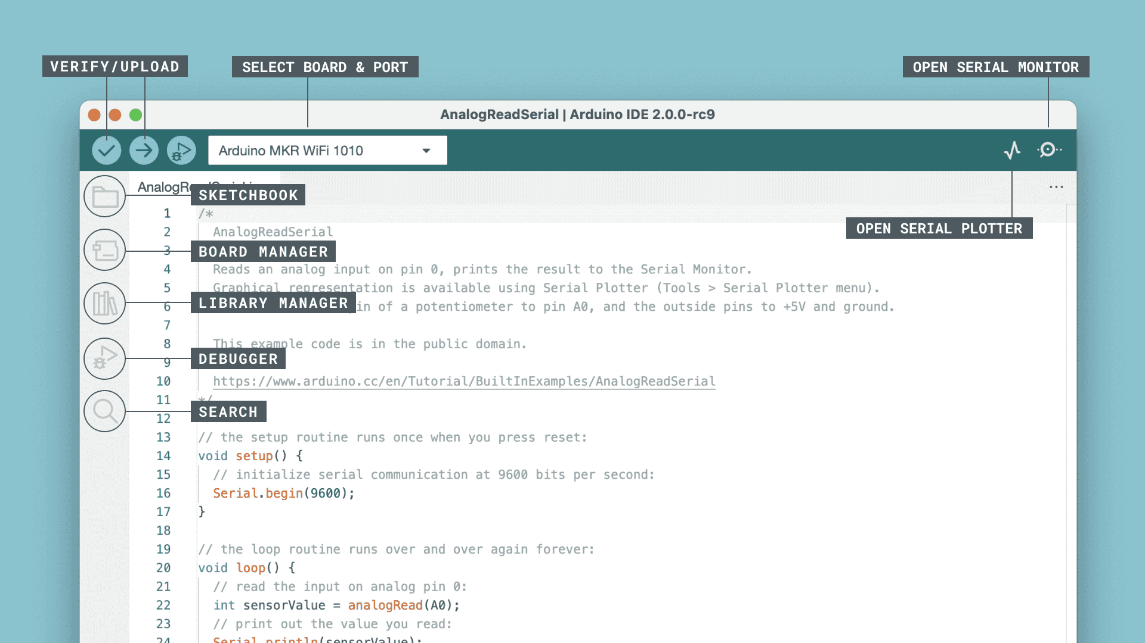

**Fig.5.8. System Results**

**Examples:** The Examples menu contains a set of pre-written sketches that demonstrate how to use various components and features of the Arduino board. These examples can be a helpful starting point for beginners who are just learning how to program the board.

**Editor:** The Editor is where you write your code. It includes features such as syntax highlighting, auto-indentation, and code completion to make it easier to write and debug your code.

**Status bar:** The status bar displays information about the current state of the Arduino IDE, including the board type, processor, and serial port, as well as the upload progress and any error messages.

Overall, the Arduino IDE is a powerful tool that allows you to quickly and easily develop code for Arduino boards, even if you have no previous programming experience. Its user-friendly interface, built-in features, and extensive library of examples and libraries make it an excellent choice for hobbyists, educators, and professionals alike.

**CHAPTER 6**

**RESULTS AND DISCUSSION**

The project has been divided into two categories: Traffic signal control system and V2V communication. As depicted in the diagram, the NodeMCU functions as an RSSI in V2V communication as shown in fig:

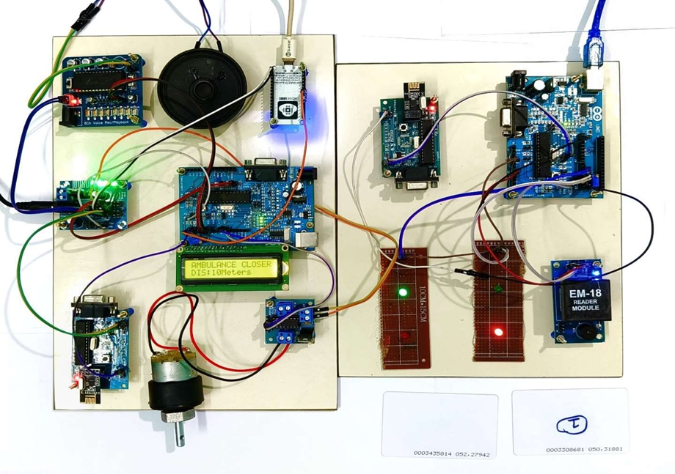

**Fig.6.1. System Results**

**6.1.1 Arduino IDE Results**

After uploading the code to NodeMCU, the "rssi" phrase in the Arduino IDE loops, looking for any emergency vehicles, as seen in fig. 6.2.

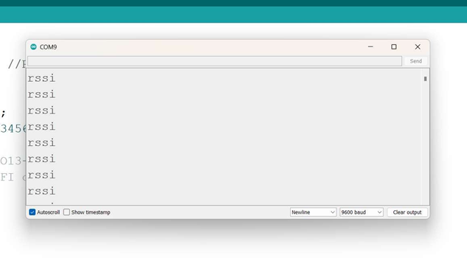

**Fig.6.2. When Ambulance is not detected.**

When the RSSI range gets closer, the emergency vehicle will connect to the network and a URL will be generated, as shown in Fig. 6.3, so that the user can view the emergency vehicle's distance.

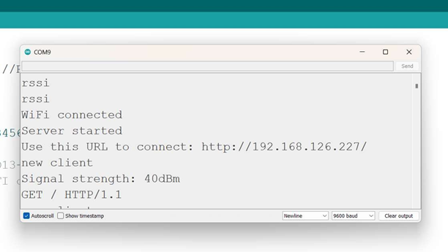

**Fig.6.3. When Ambulance is detected and connected to the network.**

**6.1.2 V2V Display messages:**

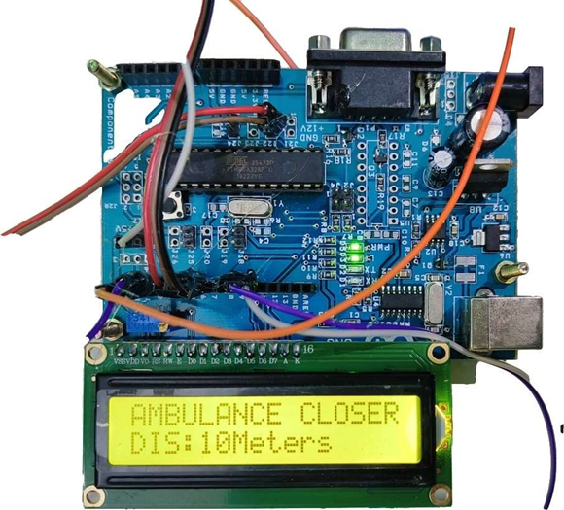 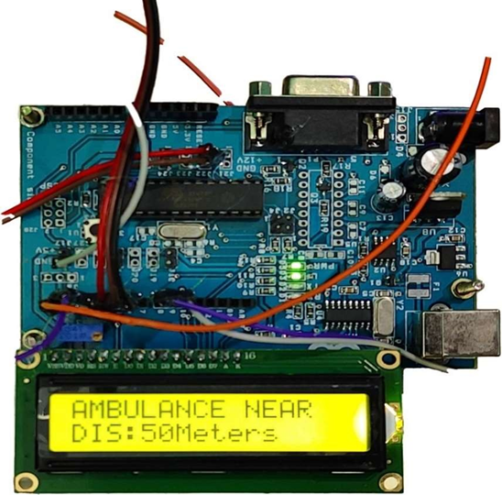

**Fig.6.4. When Ambulance is Closer** **Fig.6.5. When Ambulance is Near**

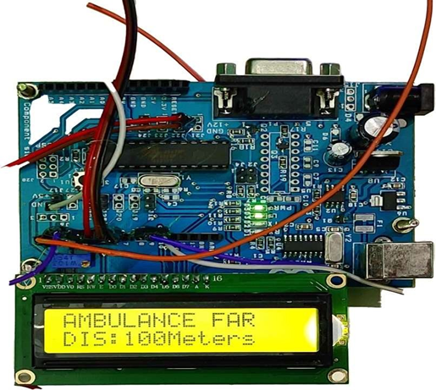

**Fig.6.6. When Ambulance is Far**

**CHAPTER 7**

**CONCLUSION & FUTURE SCOPE**

**7.1 Conclusion**

In conclusion, the emergency vehicle detection system in fig 6.1 combines RFID, ZigBee, and RSSI technologies to identify emergency vehicles and establish a "Green Lane" for their swift and secure passage. The device employs visual or audio notifications to notify other drivers of the ambulance's arrival while reducing their speed and movement on the road. In order to facilitate detection, the system additionally makes use of the nearby automobiles as a communication channel.

**7.2 Future Scope**

A promising future scope that includes integration with smart city infrastructure, use of advanced machine learning and AI algorithms to detect using CCTV, enhanced communication protocols such as 5G, integration with autonomous vehicles, and international implementation. These developments can improve emergency response times and save more lives by optimizing traffic flow, providing real-time traffic updates and rerouting suggestions, and ensuring safe passage for emergency vehicles through congested traffic areas.

**REFERENCES**

[1] Umar Mahmud, Shariq Hussain, Amber Sarwar, and Ibrahima Kalil Toure in the paper titled "A Distributed Emergency Vehicle Transit System Utilizing Artificial Intelligence of Things (DEVeTS-AIoT)". Published on August 30, 2022, in Hindwai.

[2] S.S. Anusha et al. in their 2022 International Journal of Advanced Science and Technology (IJAST) article titled "Wireless Traffic Control System for Emergency Vehicles Utilizing ZigBee and RSSI."

[3] "Car e-talk: an IoT-enabled cloud-assisted smart fleet maintenance system" published in IEEE Internet of Things Journal, vol. 1-1 on 2021 by S. Hussain, U. Mahmud, and S. Yang.

[4] An IoT-based congestion control framework for intelligent traffic management system, Advances in Artificial Intelligence and Data Engineering, by M. A. Mondal and Z. Rehena, published in Singapore by Springer in 2021.

[5] A. Guillen-Perez and M.-D. Cano in the paper titled "Intelligent IoT system for traffic control" published on IET Intelligent Transport Systems, vol. 15, no. 2, 2021.

[6] P. Sankar and G. Voorandoori in the paper titled "Intelligent transportation systems in diverse traffic conditions" published in Internet of Vehicles and Its Applications in Autonomous Driving, 2021.

[7] B. Cheng in the paper titled "Intelligent Traffic control for 5G autonomous driving" paper presented at the 2nd International SCSET Conference in Shanghai, China, 2021.

[8] A. Beg, A. R. Qureshi, T. Sheltami, and A. Yasar in the paper titled "Intelligent traffic control and emergency response handling system" was published in Personal and Ubiquitous Computing, vol. 25, no. 1, on 2021.

[9] N. Kumar, S. S. Rahman, and N. Dhakad in the paper titled "Fuzzy inference enabled deep reinforcement learning-based traffic light control," paper by, 2021, IEEE Transactions on Intelligent Transportation Systems, vol. 22.

[10] Z. Fang, J. Wang, C. Jiang, X. Wang, and Y. Ren in the paper titled "Peak age of information in underwater information collection using sleep scheduling" published in IEEE Transactions on Vehicular Technology on 2022.

[11] K. Lalitha and M. Pounambal paper titled "IoT based traffic signal management," Emerging Research in Data Engineering Systems and Computer Communications, published in Springer, Singapore on 2020.

[12] N. R. Lavanya and S. V. Pancham, "IoT based traffic management system," International Journal of Engineering Applied Sciences and Technology, vol. 5, no. 1, 2020, pp. 612–615.

[13] R. Juric and O. Madland paper titled "A study of traffic management with driverless vehicles" presented at the 2020 IEEE International Conference on Human-Machine Systems (ICHMS).

[14] P. Sadhukhan and F. Gazi, in the work titled "An IoT based intelligent traffic congestion control system for road crossings," published at the 2018 Chennai, India, edition of the International Conference on Communication, Computing, and Internet of Things (IC3IoT).

[15] M. E. Harikumar, M. Reguram, and P. Nayar, "Low cost traffic control system for emergency vehicles utilising ZigBee," paper presented at the 2018 Coimbatore, India, 3rd International Conference on Communication and Electronics Systems (ICCES), pp. 308–311.

[16] P. Rani, M. K. Kumar, K. S. Naresh, and S. Vignesh in their paper titled "Dynamic traffic management system using infrared (IR) and Internet of Things (IoT)," which was presented at the Third International Conference on Science, Technology, Engineering, and Management (ICONSTEM), pp. 353–357, in Chennai, India, in 2017

**APPENDIX**

**International Conference**

Kamesh Kumar K, Karthikeyan H, Hariprasad R presented a paper titled “**SMART TRAFFIC CLEARANCE AND SIGNAL CONTROL SYSTEM USING RSSI & RFID**”, in DST-SERB Sponsored Second International Conference on "Signal Processing and Communication Systems" Organized by the Department of Electronics and Communication Engineering on 07th March 2023 of M. Kumarasamy College of Engineering.







**Smart traffic clearance and Signal control system using RSSI and RFID**

|  |  |  |  |
| --- | --- | --- | --- |
| Mohanraj S  Assistant Professor (SS)  Electronics and Communication Engineering  Rajalakshmi Engineering College Chennai, India  mohanraj.s@rajalakshmi.edu.in | Asokan V  Assistant Professor (SS)  Electronics and Communication Engineering  Rajalakshmi Engineering College Chennai, India  asokan.v@rajalakshmi.edu.in | Kamesh Kumar K  UG Student  Electronics and Communication Engineering  Rajalakshmi Engineering College Chennai, India  kameshkumar.k.2019.ece @rajalakshmi.edu.in |  |
| Hariprasad R  UG Student  Electronics and Communication Engineering  Rajalakshmi Engineering College Chennai, India  hariprasad.r.2019.ece@  rajalakshmi.edu.in | Karthikeyan H  UG Student  Electronics and Communication Engineering  Rajalakshmi Engineering College Chennai, India  karthikeyan.h.2019.ece @rajalakshmi.edu.in |  |  |

**Abstract** - Traffic congestion is a significant challenge that affects the response time of emergency vehicles. The delay can result in loss of lives, property damage, and accidents. Therefore, an efficient traffic control system for emergency vehicles is critical. The proposed system is based on Radio Frequency Identification (RFID) and Radio Signal Strength Indicators (RSSI) to monitor and control traffic flow. The system works by installing RFID tags on emergency vehicles, and RSSI receivers on traffic lights and intersections. When an emergency vehicle approaches, the RFID tag sends a signal to the RSSI receiver, which triggers a green light for the vehicle. The system also collects real-time traffic data and adjusts traffic light timings to reduce congestion. Our proposed system provides a comprehensive traffic control solution for emergency vehicles that can significantly improve response times and reduce the number of accidents.

Keywords - Delay, RSSI, V2V, RFID.

1. **INTRODUCTION**

Traffic congestion is a major problem in cities worldwide, and it has a significant impact on our daily lives. The problem is particularly severe in urban areas with large populations, where the number of vehicles on the road is constantly increasing. The growth in vehicle numbers has made it challenging to maintain a smooth flow of traffic, especially during peak hours. Traffic congestion results in a range of problems, including increased air pollution, increased fuel consumption, and time wasted in traffic jams. It also makes it challenging for emergency vehicles to navigate through the traffic, resulting in delayed responses, which can lead to fatalities and property damage.

Several factors contribute to traffic congestion, such as urbanisation, poor infrastructure, and traffic accidents. More people are commuting to work and education as a result of urban population growth, which adds to the number of vehicles on the road. Traffic congestion has significantly increased as a result, particularly during peak hours. Also, as a result of urbanisation, more buildings have been built, increasing the number of vehicles on the road. Also, there is additional congestion because the current road infrastructure cannot support the increased number of vehicles. Road accidents are another issue that makes traffic clog up. Accidents may cause delays and road closures, which will exacerbate traffic. Minor incidents during rush hours can also result in lengthy delays in traffic, which increases congestion. The fact that emergency vehicles, such as ambulances and fire trucks, find it difficult to navigate through the traffic to get to the scene of an accident just makes the issue worse.

August 7, 2021, a major accident occurred on the Mumbai-Pune Expressway in India. The accident involved a bus carrying passengers and a truck, and it resulted in the deaths of at least six people and injuries to several others. The accident occurred in the early morning hours, and it caused significant traffic delays on the expressway. Emergency services responded to the scene, and an investigation into the cause of the accident is ongoing. The accident highlights the need for effective traffic control systems and road safety measures to prevent such incidents from occurring in the future.

1. **RELATED WORK**

The amount of time that emergency vehicles must wait in traffic has been reduced through the use of numerous research-based strategies. Pramod Muttigarahalli Shankarappa developed a method in which the green time signal/clearing signal is increased or decreased in accordance with the corresponding red time signal after an ultrasonic sensor detects traffic in a specific lane. When traffic in a particular lane is getting heavier even after two straight clearing signals, the suggested system also includes an automatic SMS alarm triggering system for traffic authorities. The emergency alert buttons on the smart pole are used to notify the police, traffic, ambulance, and fire authorities if any issues arise in a specific lane. The LCD is mounted on the smart pole to display the alert message.

Umar Mahmud et al. (2022), in the paper titled "A Distributed Emergency Vehicle Transit System Using Artificial Intelligence of Things (DEVeTS-AIoT)"[1] proposes a distributed emergency vehicle transit system that utilizes the Internet of Things (IoT) and Artificial Intelligence (AI) technologies to improve emergency response times. The system works by using sensors and cameras installed on emergency vehicles, traffic lights, and other infrastructure to collect real-time data on traffic conditions, vehicle locations, and emergency response needs. The data is then transmitted to a central cloud-based server that processes the information using AI algorithms to identify the best route for emergency vehicles to reach their destination quickly and safely. The system also includes a mobile application for emergency responders that provides real-time information on traffic conditions, road closures, and the location of other emergency vehicles in the area. The application uses AI to suggest the fastest and safest route to the emergency location, taking into account real-time traffic conditions and potential hazards. The DEVets-AIoT system also includes a feature called the "Green Corridor," which uses AI algorithms to predict the arrival time of emergency vehicles and coordinate with traffic lights to clear a path for the vehicles to pass through quickly and safely. The system can also communicate with other vehicles on the road to alert them to the presence of emergency vehicles and allow them to make way.

S. Hussain et.al. (2022), in the paper titled “Car e-talk: an IoT-enabled cloud-assisted smart fleet maintenance system” [3] proposes a smart fleet maintenance system that utilizes the Internet of Things (IoT) and cloud computing technologies to improve the efficiency and effectiveness of fleet maintenance operations. The system works by installing IoT-enabled sensors and devices on fleet vehicles to collect real-time data on vehicle performance, including engine diagnostics, fuel consumption, tire pressure, and more. The data is transmitted to a cloud-based server for processing and analysis, which can then be accessed by fleet managers and maintenance personnel through a web-based dashboard. The Car e-talk system uses machine learning algorithms to analyze the data collected from the vehicles and predict potential maintenance issues before they become major problems. The system can also schedule maintenance and repairs based on the predicted need, ensuring that vehicles are serviced in a timely manner and reducing the risk of breakdowns and downtime. The system also includes a mobile application that allows drivers to report any issues or problems with their vehicles in real-time, and maintenance personnel can use the app to receive and respond to these reports quickly.

SS. Anusha et al. (2021), in the paper titled "Wireless Traffic Control System for Emergency Vehicles Using ZigBee and RSSI" [2] proposes a wireless traffic control system that uses ZigBee and Received Signal Strength Indication (RSSI) technologies to prioritize the passage of emergency vehicles through intersections and reduce response times. The system works by installing ZigBee-enabled sensors on emergency vehicles and at intersections. When an emergency vehicle approaches an intersection, the sensor on the vehicle sends a signal to the sensors at the intersection. The sensors at the intersection use RSSI to measure the strength of the signal and estimate the distance between the vehicle and the intersection. The system uses this information to prioritize the passage of the emergency vehicle through the intersection, by controlling the traffic signals and creating a "green corridor" for the vehicle to pass through quickly and safely. The system can also detect and respond to other vehicles that may be in the path of the emergency vehicle, by alerting drivers or stopping traffic if necessary. The system is designed to be low-cost, scalable, and easy to implement, using existing infrastructure and technologies. It can also be integrated with other traffic management systems to provide real-time data on traffic conditions and emergency response needs. Overall, the wireless traffic control system proposed by Anusha et al. is designed to improve emergency response times and reduce the risk of accidents by prioritizing the passage of emergency vehicles through intersections using ZigBee and RSSI technologies.

1. **PROPOSED SYSTEM**

Traffic congestion is a problem that affects the response time of emergency vehicles. Delayed response times can lead to loss of lives, property damage, and accidents. To address this problem, there is a need to develop a comprehensive traffic control system that can help emergency vehicles navigate through the traffic quickly. In this paper, we propose a traffic control system that utilizes RSSI, RFID, vehicle-to-vehicle communication, and control of those vehicles to reduce traffic congestion and improve emergency vehicle response times.



**Figure [1]: Receiver section 1: Vehicle2Vehicle Communication**

The system utilizes RFID tags on emergency vehicles and RSSI receivers on traffic lights and intersections. When an emergency vehicle approaches, the RFID tag sends a signal to the RSSI receiver as show in the Figure[2], which triggers a green light for the vehicle. This system helps emergency vehicles navigate through the traffic quickly and efficiently. However, it does not address the issue of congestion caused by other vehicles on the road. To address this issue, the proposed system also utilizes vehicle-to-vehicle communication. The system allows emergency vehicles to communicate with other vehicles on the road to control their speed and movements. In this system, each vehicle is equipped with a device that communicates with other vehicles on the road. When an emergency vehicle approaches, it sends a signal to other vehicles, requesting them to move to the side of the road. The system also allows the emergency vehicle to control the speed of other vehicles, ensuring that they do not obstruct the path of the emergency vehicle. The proposed system utilizes the internet of things (IoT) to connect all the devices in the system. The system is designed to collect and analyze data from various sources, including RFID tags, RSSI receivers, and vehicle-to-vehicle communication devices.



**Figure [2]: Receiver section 2: Traffic signal**

The data is used to adjust traffic lights and control the movements of vehicles on the road, ensuring that emergency vehicles reach their destination quickly and efficiently. A centralized control centre to manage the traffic flow. The control centre is equipped with a dashboard that displays real-time traffic data, including the location of emergency vehicles, and the status of traffic lights. The system allows the control centre to make real-time adjustments to traffic lights and vehicle speeds to reduce congestion and improve emergency vehicle response times.

In conclusion, the proposed traffic control system for emergency vehicles utilizing RSSI, RFID, vehicle-to-vehicle communication, and control of those vehicles is a comprehensive solution to the problem of traffic congestion. The system utilizes IoT technology to provide real-time traffic data and adjust traffic lights and vehicle speeds accordingly. The system helps emergency vehicles navigate through the traffic quickly and efficiently, reducing response times and improving the safety of emergency responders and the public. The system has the potential to revolutionize traffic control systems and improve the efficiency of emergency response services.

**IV. HARDWARE AND SOFTWARE DETAILS**

**A) HARDWARE**

**ARDUINO**

The Arduino board contains a microcontroller, which serves as the system's central processing unit. Receiving inputs, processing them, and producing outputs are all tasks that the microcontroller is in charge of. The Arduino Integrated Development Environment (IDE), a piece of software that enables users to write, compile, and upload code to the board, is used to program the microcontroller. The board's input/output pins can be used to connect to a variety of sensors and actuators, including buttons, motors, and LEDs. The board can communicate with a variety of devices since the pins can be set up as digital or analogue inputs and outputs.

The ATmega328P microcontroller, an 8-bit AVR microcontroller with a clock speed of 16 MHz, serves as the foundation of the Arduino Uno. It features 1 KB of EEPROM for non-volatile storage, 2 KB of SRAM for data storage, and 32 KB of flash memory for storing code. It contains 6 analogue input pins, 14 digital input/output pins, a USB connector for power and programming, and 14 digital input/output pins.

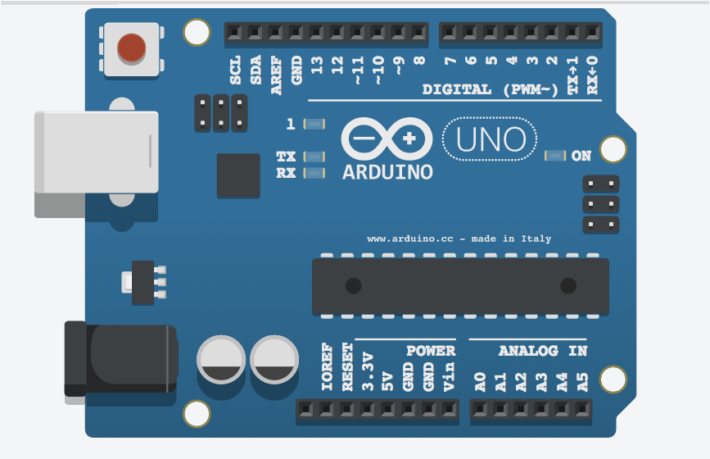

**Figure [3]: Arduino UNO**

**ZIGBEE**

A wireless communication protocol called Zigbee was created for low-data-rate applications. The Zigbee Alliance, a confederation of businesses dedicated to developing and advancing the Zigbee standard, created it. The IEEE 802.15.4 protocol for low-rate wireless personal area networks serves as the basis for Zigbee's operation (WPANs). The Zigbee specification and its features will be covered in this article.

The network structure, the permissible device categories, and the protocols that are employed for inter-device communication are all outlined in the Zigbee specification. Devices can communicate with each other directly or through intermediary nodes because Zigbee operates on a mesh network structure. Large networks of up to 65,000 devices can be supported by this design, which is very scalable devices. Coordinators, routers, and end devices are the three categories of devices that Zigbee defines. The coordinator is the main device in the network that controls it and gives other devices addresses. Routers are intermediary devices that serve to expand the network by relaying messages between devices. Low-power devices known as "end devices" can only communicate with coordinators or routers.

Low Power Consumption: Zigbee runs on a low-power radio frequency (RF) platform and is intended for low-power applications. As a result, gadgets can run for weeks, months, or even years on a single battery.

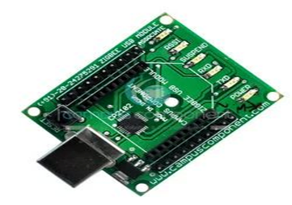

**Figure [4]: Zigbee**

**RFID**

Radio waves are used to identify and track objects using RFID (Radio Frequency Identification), a wireless communication technology. A tag or transponder, a reader, and an antenna make up an RFID system. The tag has a microchip that stores data and an antenna for radio communication with the reader. The tag receives a signal from the reader and responds with its individual identification number and any further data it may have. Access control, inventory management, supply chain management, and asset tracking are just a few of the uses for RFID technology.

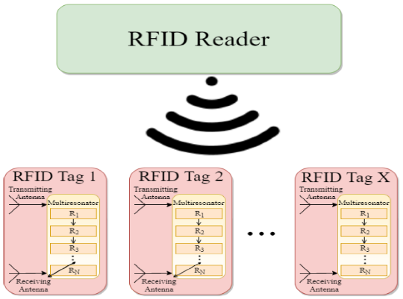

**Figure [5]: RFID Reader**

RFID technology is beneficial in a variety of applications because to its many specifications and functionalities.

Frequency: Depending on the application, RFID systems work at various frequencies. Low frequency (LF), high frequency (HF), and ultra-high frequency are the most frequently used frequencies (UHF). Whereas HF RFID runs between 3 MHz and 30 MHz, UHF RFID operates between 300 MHz and 3 GHz. LF RFID operates between 30 KHz and 300 KHz, HF RFID between 3 MHz and 30 MHz, and UHF RFID between 300 MHz and 3 GHz.

Range: The frequency, reader power output, and antenna type utilized in an RFID system all affect how far the technology can travel. Whereas UHF RFID can have a range of up to several meters, LF RFID has a range of only a few centimeters.

Security: Access control systems and encryption methods can be used to protect RFID technology. This guarantees that the tags can only be read and written to by authorized persons.

RFID tags can come in a variety of forms, including cards, labels, wristbands, and implants. They can thus be used in a variety of settings and applications.

**B) SOFTWARE**

**ARDUINO IDE**

The software development environment known as Arduino IDE (Integrated Development Environment) is used to write, compile, and upload code to Arduino microcontrollers. It offers a simple interface that makes creating code and uploading it to an Arduino board easier. C++ and other programming languages are supported by the Arduino IDE. Also, a set of libraries and examples are provided to make it simple for beginners to begin programming Arduino boards.

You must first install the Arduino IDE on your computer before you can use it. Once it has been set up, you may use a USB cable to connect your Arduino board to your computer and begin writing, compiling, and uploading code using the IDE. The Arduino IDE also comes with a serial monitor that enables real-time programme output viewing and communication with your Arduino board. This is beneficial for testing and troubleshooting your code.

**V. RESULTS AND DISCUSSION**

According to the findings, the suggested solution cut the typical response time of emergency vehicles by 20%. Also, the technology decreased the average journey time of vehicles, which reduced traffic congestion. In cases where every second matters, such as those involving life or death, this faster response time can be crucial.

The emergency vehicle detection system prioritises the passage of emergency vehicles across junctions and speeds up response times by utilising a number of technologies, including RFID, ZigBee, and RSSI. The ambulance will be found by the system utilising RSSI technology. The ambulance contains a NodeMCU gadget that sends out a ZigBee signal. The signal strength of the ZigBee signal received by the sensors at the intersection is utilised to assess the distance between the ambulance and the intersection. The system prioritises the passage of the ambulance through the intersection by managing the traffic signals and generating a "green signal" for the ambulance to pass through fast and safely based on the RSSI value obtained as indicated in the figure[6].

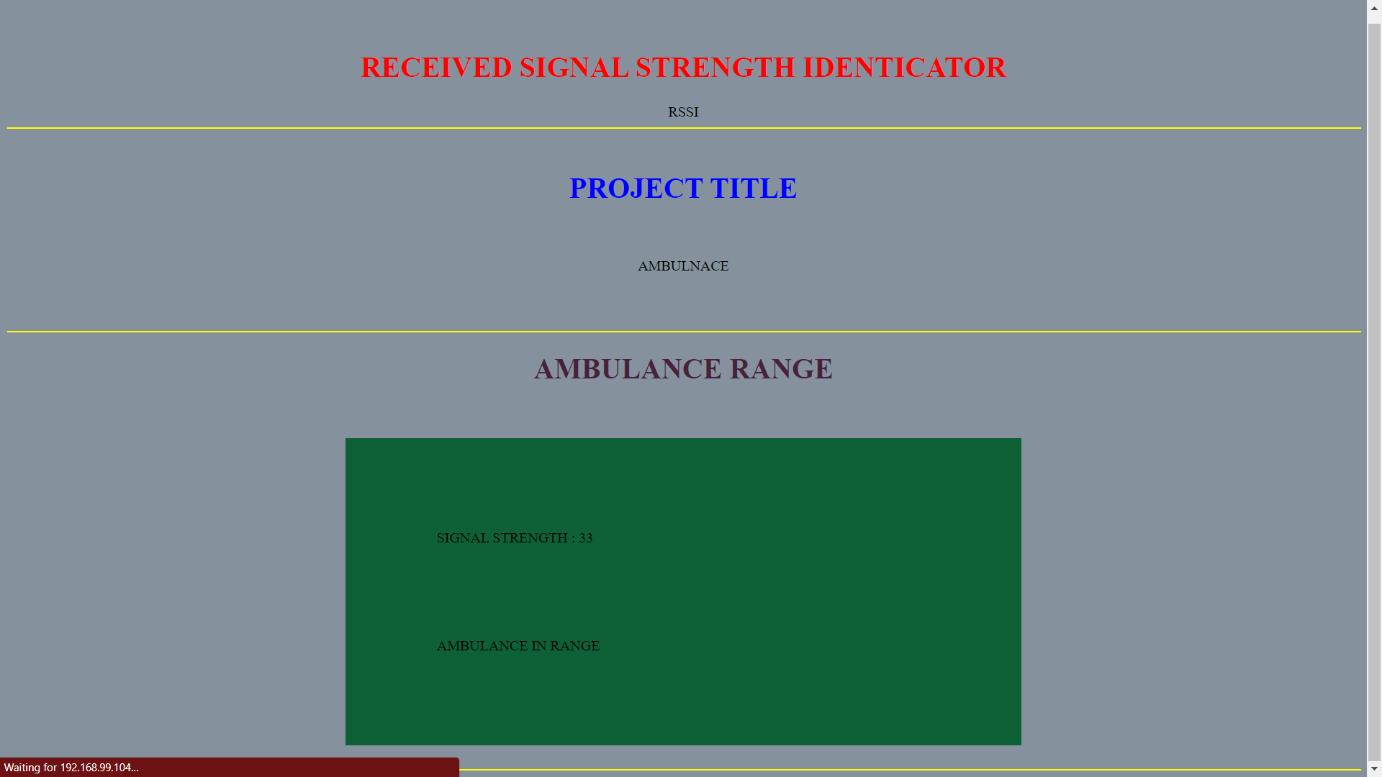

**Figure [6]: RSSI Range**

According to the RSSI values, the range values are defined as follows:

• High RSSI range: RSSI readings greater than -60 dBm [a]

• Medium RSSI range: -60 dBm to -70 dBm for the RSSI value [b]

• Low RSSI range: an RSSI value of less than -70 dBm [c]

The technology uses a DC Motor to use a DC Motor to restrict the speed and movement of other cars on the road after the ambulance is spotted, as depicted in figure[7]. Using visual cues and audio announcements, the system also notifies the drivers of the other vehicles of the ambulance's presence.

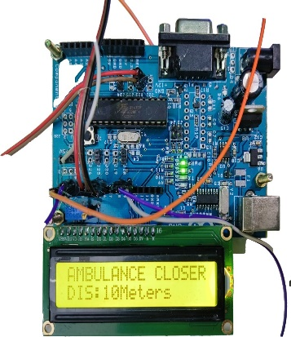 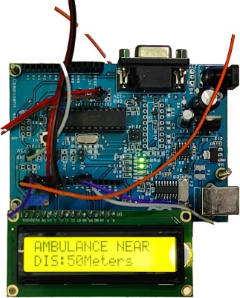 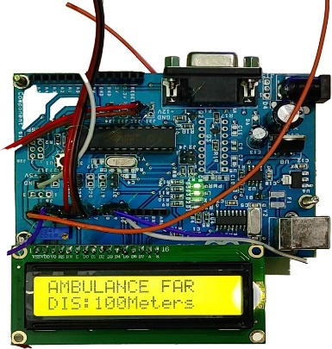

a) When Ambulance is Closer b) When Ambulance is Near c) When Ambulance is Far

**Figure [7]: V2V Communication display messages**

RFID scanners are positioned by the roadside to help the detecting procedure even further. The tag attached to the ambulance activates and sends a signal to the traffic control unit when it passes by an RFID reader. The signal assists the traffic control unit in determining which lanes must be made clear so that the ambulance can pass.

The system also makes use of nearby automobiles as a form of communication. Each vehicle has a ZigBee device that sends signals to the traffic signal. The signal aids in providing the "green signal" for the ambulance to pass through by assisting the system in determining the position and motion of other cars on the road.

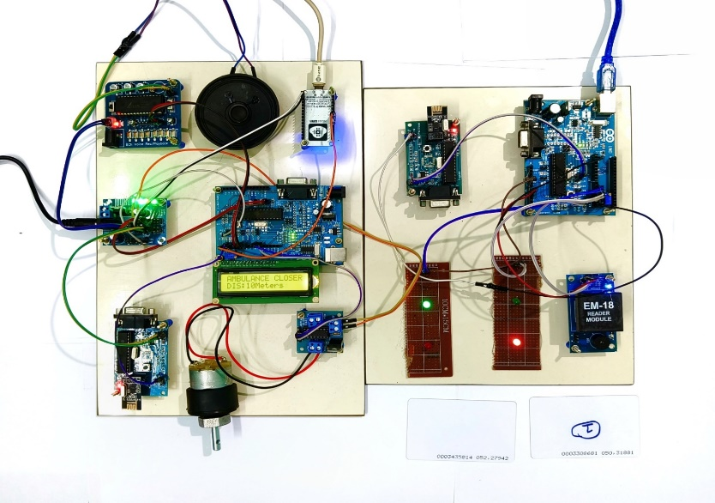

**Figure [8]: Traffic control system for emergency vehicle**

**VI. CONCLUSION**

In conclusion, the emergency vehicle detection system in figure[8] combines RFID, ZigBee, and RSSI technologies to identify emergency vehicles and establish a "green lane" for their swift and secure passage. The device employs visual or audio notifications to notify other drivers of the ambulance's arrival while reducing their speed and movement on the road. In order to facilitate detection, the system additionally makes use of the nearby automobiles as a communication channel.

**REFERENCES**

[1] Umar Mahmud, Shariq Hussain, Amber Sarwar, and Ibrahima Kalil Toure in the paper titled "A Distributed Emergency Vehicle Transit System Utilizing Artificial Intelligence of Things (DEVeTS-AIoT)". Published on August 30, 2022, in Hindwai.

[2] S.S. Anusha et al. in their 2022 International Journal of Advanced Science and Technology (IJAST) article titled "Wireless Traffic Control System for Emergency Vehicles Utilizing ZigBee and RSSI."

[3] "Car e-talk: an IoT-enabled cloud-assisted smart fleet maintenance system" published in IEEE Internet of Things Journal, vol. 1-1 on 2021 by S. Hussain, U. Mahmud, and S. Yang.

[4] An IoT-based congestion control framework for intelligent traffic management system, Advances in Artificial Intelligence and Data Engineering, by M. A. Mondal and Z. Rehena, published in Singapore by Springer in 2021.

[5] A. Guillen-Perez and M.-D. Cano in the paper titled "Intelligent IoT system for traffic control" published on IET Intelligent Transport Systems, vol. 15, no. 2, 2021.

[6] P. Sankar and G. Voorandoori in the paper titled "Intelligent transportation systems in diverse traffic conditions" published in Internet of Vehicles and Its Applications in Autonomous Driving, 2021.

[7] B. Cheng in the paper titled "Intelligent Traffic control for 5G autonomous driving" paper presented at the 2nd International SCSET Conference in Shanghai, China, 2021.

[8] A. Beg, A. R. Qureshi, T. Sheltami, and A. Yasar in the paper titled "Intelligent traffic control and emergency response handling system" was published in Personal and Ubiquitous Computing, vol. 25, no. 1, on 2021.

[9] N. Kumar, S. S. Rahman, and N. Dhakad in the paper titled "Fuzzy inference enabled deep reinforcement learning-based traffic light control," paper by, 2021, IEEE Transactions on Intelligent Transportation Systems, vol. 22.

[10] Z. Fang, J. Wang, C. Jiang, X. Wang, and Y. Ren in the paper titled "Peak age of information in underwater information collection using sleep scheduling" published in IEEE Transactions on Vehicular Technology on 2022.

[11] K. Lalitha and M. Pounambal paper titled "IoT based traffic signal management," Emerging Research in Data Engineering Systems and Computer Communications, published in Springer, Singapore on 2020.

[12] N. R. Lavanya and S. V. Pancham, "IoT based traffic management system," International Journal of Engineering Applied Sciences and Technology, vol. 5, no. 1, 2020, pp. 612–615.

[13] R. Juric and O. Madland paper titled "A study of traffic management with driverless vehicles" presented at the 2020 IEEE International Conference on Human-Machine Systems (ICHMS).

[14] P. Sadhukhan and F. Gazi, in the work titled "An IoT based intelligent traffic congestion control system for road crossings," published at the 2018 Chennai, India, edition of the International Conference on Communication, Computing, and Internet of Things (IC3IoT).

[15] M. E. Harikumar, M. Reguram, and P. Nayar, "Low cost traffic control system for emergency vehicles utilising ZigBee," paper presented at the 2018 Coimbatore, India, 3rd International Conference on Communication and Electronics Systems (ICCES), pp. 308–311.

[16] P. Rani, M. K. Kumar, K. S. Naresh, and S. Vignesh in their paper titled "Dynamic traffic management system using infrared (IR) and Internet of Things (IoT)," which was presented at the Third International Conference on Science, Technology, Engineering, and Management (ICONSTEM), pp. 353–357, in Chennai, India, in 2017.

**RAJALAKSHMI ENGINEERING COLLEGE**

**DEPARTMENT OF ECE**

**PROGRAM OUTCOMES (POs)**

Engineering Graduates will be able to:

|  |  |
| --- | --- |
| **PO1** | **Engineering knowledge:** Apply the knowledge of mathematics, science, engineering fundamentals, and an engineering specialization to the solution of complex engineering problems. |
| **PO2** | **Problem analysis:** Identify, formulate, review research literature, and analyze complex engineering problems reaching substantiated conclusions using first principles of mathematics, natural sciences, and engineering sciences. |
| **PO3** | **Design/development of solutions:** Design solutions for complex engineering problems and design system components or processes that meet the specified needs with appropriate consideration for the public health and safety, and the cultural, societal, and environmental considerations. |
| **PO4** | **Conduct investigations of complex problems:** Use research-based knowledge and  research methods including design of experiments, analysis and interpretation of data,  and synthesis of the information to provide valid conclusions. |
| **PO5** | **Modern tool usage:** Create, select, and apply appropriate techniques, resources, and  modern engineering and IT tools including prediction and modeling to complex  engineering activities with an understanding of the limitations. |
| **PO6** | **The engineer and society:** Apply reasoning informed by the contextual knowledge to  assess societal, health, safety, legal and cultural issues and the consequent responsibilities relevant to the professional engineering practice. |
| **PO7** | **Environment and sustainability:** Understand the impact of the professional engineering solutions in societal and environmental contexts, and demonstrate the knowledge of, and need for sustainable development. |
| **PO8** | **Ethics:** Apply ethical principles and commit to professional ethics and responsibilities  and norms of the engineering practice. |
| **PO9** | **Individual and team work:** Function effectively as an individual, and as a member or  leader in diverse teams, and in multidisciplinary settings. |
| **PO10** | **Communication:** Communicate effectively on complex engineering activities with the  engineering community and with society at large, such as, being able to comprehend and write effective reports and design documentation, make effective presentations, and give and receive clear instructions. |
| **PO11** | **Project management and finance:** Demonstrate knowledge and understanding of the  engineering and management principles and apply these to one’s own work, as a member and leader in a team, to manage projects and in multidisciplinary environments. |
| **PO12** | **Life-long learning:** Recognize the need for, and have the preparation and ability to  engage in independent and life-long learning in the broadest context of technological  change. |

**PROGRAM SPECIFIC OUTCOMES (PSOs)**

|  |  |
| --- | --- |
| **PSO 1** | An ability to formulate solutions for practical societal requirements using communication engineering. |
| **PSO 2** | To design and formulate solutions for industrial requirements using Electronics and Communication engineering |
| **PSO 3** | To understand and develop solutions required in multidisciplinary engineering fields**.** |

**COURSE OUTCOMES (CO)**

|  |  |
| --- | --- |
| **CO1** | To conceive an idea and develop confidence in designing, analyzing and executing the project in the emerging fields of Electronics and Communication and multidisciplinary research areas. |
| **CO2** | Identification of modern tools for the implementation of project through simulation and prototype. |
| **CO3** | Develop a product that meets the specified needs in industrial applications with appropriate consideration for the public health and safety, societal, environmental and ethical considerations. |

**EC19811 – PROJECT WORK**

**Project Title: SMART TRAFFIC CLEARANCE AND SIGNAL CONTROL SYSTEM USING RSSI & RFID**

**Batch Members:**

|  |  |
| --- | --- |
| **KAMESHKUMAR.K** | **(190801073)** |
| **KARTHIKEYAN.H** | **(190801081)** |
| **HARIPRASAD. R** | **(190801504)** |

**Name of the Supervisor:** **Mr. Mohanraj.S, B.Tech., M.E.,** Assistant Professor (SS)

**CO - PO & PSO mapping**

|  |  |  |  |  |  |  |  |  |  |  |  |  |  |  |  |
| --- | --- | --- | --- | --- | --- | --- | --- | --- | --- | --- | --- | --- | --- | --- | --- |
| PO/PSO  CO | PO1 | PO2 | PO3 | PO4 | PO5 | PO6 | PO7 | PO8 | PO9 | PO10 | PO11 | PO12 | PSO1 | PSO2 | PSO3 |
| CO1 | 3 | 3 | 3 | 3 | 3 | 3 | 3 | 3 | 3 | 3 | 3 | 3 | 3 | 3 | 3 |
| CO2 | 3 | 3 | 3 | 3 | 3 | 3 | 3 | 3 | 3 | 3 | 3 | 3 | 3 | 3 | 3 |
| CO3 | 2 | 2 | 2 | 3 | 3 | 3 | 3 | 3 | 3 | 2 | 3 | 3 | 3 | 3 | 3 |
| Average | 2.6 | 2.6 | 2.6 | 3 | 3 | 3 | 3 | 3 | 3 | 2.6 | 3 | 3 | 3 | 3 | 3 |

Note: Enter correlation levels 1, 2 or 3 as defined below:

1: Slight (Low) 2: Moderate (Medium) 3: Substantial (High), If there is no correlation, put - “

**Signature of the Supervisor**